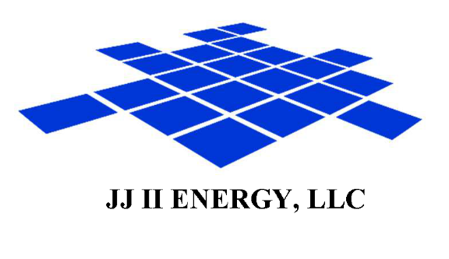

August 28, 2019

Re: Landman Opportunity

To Whom It May Concern,
I have worked in the Oil/Gas industry as a Landman since 2008. Working on projects in Louisiana, Oklahoma, Colorado, Wyoming, Utah, Texas, and New Mexico.
I have worked on projects ranging from lease acquisitions, mineral/royalty acquisitions, title research, abstracting, and title curative. I am currently working on curative issues and assembling abstracts in the Permian Basin of Texas and New Mexico. Along with abstracting and curing title, I determine the complicated ownership of all interests in HBP lands, then compose and submit a Mineral Ownership Report and a DOI deck. I am based in Lafayette, LA, and have two field landmen that I oversee in assisting me with title research and abstract assembly.
As my resume indicates, I have the background and experience our industry demands and your company needs. I possess 7+ years of progressive experience as a Petroleum Landman in title research, lease negotiations, Title Opinions, multiple computer programs, and more!
I am more than qualified; moreover, my ambitions, my ability to adapt and learn quickly, my experience, track record, and overall skillset will exceed your company’s expectations, resulting in promptly & correctly completed assignments, and a highly satisfied Client.
I am willing to relocate at my own expense.

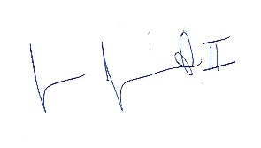
Sincerely,

Jason Jumonville II, RPL

